Aim:
The aim of implementing the Composite design pattern in this context is to create a menu system capable of representing hierarchical structures of menus and menu items.

Description:
The Composite pattern enables hierarchical menu systems where menus can contain both items and submenus, offering a uniform interface for manipulation. It simplifies code by treating individual items and entire menus uniformly. This flexibility allows for easy addition of new elements without altering existing code, enhancing extensibility and maintainability. Leveraging recursion, operations like displaying the menu structure are streamlined. Overall, the pattern provides an elegant solution for representing and managing complex hierarchical structures, promoting code reuse and organizational clarity in menu systems.

Code:

1. MenuExample.java

package Personal;

import java.util.ArrayList;
import java.util.List;
import java.util.Scanner;

// Component interface
interface MenuComponent {
void display();
}

// Leaf class representing a single menu item
class MenuItem implements MenuComponent {
private String name;

public MenuItem(String name) {
this.name = name;
}

public void display() {
System.out.println(name);
}}

// Composite class representing a menu containing submenus or menu items
class Menu implements MenuComponent {
private String name;
private List<MenuComponent> menuComponents = new ArrayList<>();

public Menu(String name) {
this.name = name;
}

public void add(MenuComponent component) {
menuComponents.add(component);
}

public void remove(MenuComponent component) {
menuComponents.remove(component);
}

public void display() {
System.out.println("Menu: " + name);
for (MenuComponent component : menuComponents) {
component.display();
}}}

public class MenuExample {
public static void main(String[] args) {
// Create main menu
Menu mainMenu = new Menu("Main Menu");

// Create submenus
Menu fileMenu = new Menu("File");
Menu editMenu = new Menu("Edit");
Menu viewMenu = new Menu("View");

// Add submenus to the main menu
mainMenu.add(fileMenu);
mainMenu.add(editMenu);
mainMenu.add(viewMenu);

// Create menu items for the submenus
MenuItem newItem = new MenuItem("New");
MenuItem openItem = new MenuItem("Open");
MenuItem saveItem = new MenuItem("Save");
MenuItem exitItem = new MenuItem("Exit");

MenuItem cutItem = new MenuItem("Cut");
MenuItem copyItem = new MenuItem("Copy");
MenuItem pasteItem = new MenuItem("Paste");

MenuItem zoomInItem = new MenuItem("Zoom In");
MenuItem zoomOutItem = new MenuItem("Zoom Out");

// Add menu items to the submenus
fileMenu.add(newItem);
fileMenu.add(openItem);
fileMenu.add(saveItem);
fileMenu.add(exitItem);
editMenu.add(cutItem);
editMenu.add(copyItem);
editMenu.add(pasteItem);

viewMenu.add(zoomInItem);
viewMenu.add(zoomOutItem);

// Display the main menu
mainMenu.display();

// Simulate user interaction by selecting a submenu
Scanner scanner = new Scanner(System.in);
System.out.print("Enter the submenu to display (File/Edit/View): ");
String selectedMenu = scanner.nextLine().trim().toLowerCase();

// Display the selected submenu
switch (selectedMenu) {
case "file":
fileMenu.display();
break;
case "edit":
editMenu.display();
break;
case "view":
viewMenu.display();
break;
default:
System.out.println("Invalid submenu selection.");
}
scanner.close();
}
}

Output:
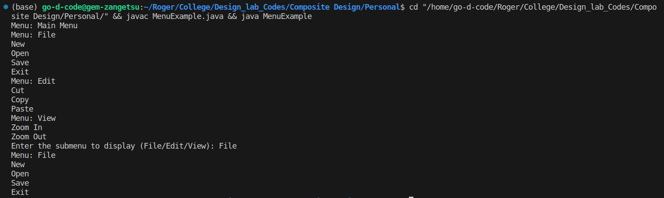
Class Diagram:

